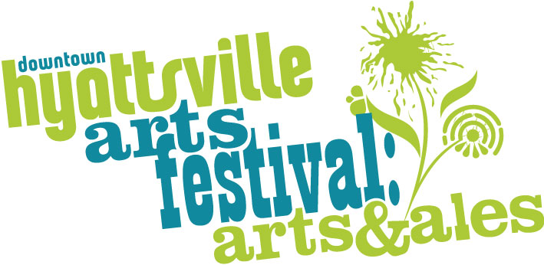
Seeking Volunteers

Are you interested in the arts or an arts career? Need service hours? Want to engage with the local and regional community in an exciting event?

The Downtown Hyattsville Arts Festival is seeking Volunteers. On September 21, 2019, our festival celebrates its 12th year! In addition to helping the artists and artisans with setting up, finding their way, and breaking down their various stations, you will have a fantastic opportunity to speak and network with regional exhibitors and performers. This is a chance to receive community service hours, and to experience the business and creativity of the fine arts first hand!

Volunteer Shifts
Opening Shift 7am-12am  20 Strong Volunteers to open the Festival, help Set Up artist area, and engage our very first festival visitors! | Event 12am to 4pm  10 Keen volunteers to assist festival visitors, engage with artists, help performing musicians and take photos and videos for social media! | Closing 4pm-8pm  20 Energetic volunteers to finish with attendees, help exhibiting artists pack up, and finish closing the festival.

If you’d like to help as an Volunteer, sign up on VolunteerLocal at https://hyattsvillearts.com/volunteer or email festival@hyattsvillecdc.org!

The Hyattsville CDC is a non-profit organization dedicated to the revitalization and sustainable development of the Hyattsville community.

